1. Introduction & Business Context
The retail company aims to improve sales performance, customer engagement, and long-term loyalty by understanding customer shopping behaviour. With evolving consumer preferences across demographics, product categories, and channels, management needs data-backed insights to optimize marketing strategies, product planning, and customer retention efforts.
This analysis uses historical customer transaction data to identify key trends related to spending habits, seasonality, discount usage, subscriptions, and customer loyalty.
2. Data Understanding
The dataset represents 3,900 customer transactions collected from an online retail platform.
Key Data Categories:
- Customer Demographics Age, gender, location, subscription status
- Purchase Information Product purchased, category, purchase amount, season, colour, size.
- Behavioural Indicators Discount usage, purchase frequency, previous purchases, review ratings, shipping type
This data provides a holistic view of who the customers are, what they buy, and how they shop.

3. Data Preparation Process
Before analysis, the dataset underwent a structured data preparation process to ensure accuracy and consistency.
3.1 Data Cleaning
- Checked for missing and inconsistent values across all columns.
- Identified missing values in customer review ratings.
- Addressed missing data to avoid skewed insights and ensure reliable averages.
3.2 Data Standardization
- Standardized column names and formats to maintain consistency.
- Ensured categorical values (e.g., gender, subscription status, discount usage) were uniform and free from duplicates or spelling variations.
3.3 Feature Creation
To enable deeper behavioural analysis, new analytical features were created:
- Age Groups: Customers were grouped into Young Adult, Adult, Middle-aged, and Senior segments.
- Customer Loyalty Indicators: Based on purchase history and frequency, customers were classified into New, Returning, and Loyal segments.
- Purchase Frequency Metric: A derived measure to understand how often customers return to shop.
This step enhanced the dataset’s analytical value beyond raw transactional data.
Analytical Framework
The analysis followed a customer-centric and business-driven framework, focusing on key questions relevant to retail decision-making.
4.1 Spending Behaviour Analysis
- Evaluated average purchase value across different customer segments.
- Compared spending patterns by gender, age group, and subscription status.
- Identified high-value customers who consistently spend above average.
Purpose:
To understand which customer groups contribute most to revenue and should be prioritized.

4.2 Discount Impact Analysis
- Assessed how discounts influence purchase behaviour.
- Compared spending levels between customers who used discounts and those who did not.
- Identified products and categories most dependent on discounts.
Purpose:
To determine whether discounts drive growth or reduce profitability.

4.3 Subscription & Loyalty Analysis
- Compared purchase frequency and average spending between subscribers and non-subscribers.
- Analyzed the relationship between repeat purchases and subscription adoption.
- Identified loyal customers who contribute significantly to total revenue.
Purpose:
To measure the effectiveness of the subscription model and customer retention strategies.

4.4 Product Performance Analysis
- Ranked products based on sales volume and revenue contribution.
- Evaluated customer review ratings to identify top-performing products.
- Compared product performance across categories.
Purpose:
To guide inventory planning, product promotions, and marketing focus.

4.5 Seasonal Trend Analysis
- Analyzed total sales across different seasons.
- Identified peak and low-performing periods.
- Evaluated how product categories perform seasonally.
Purpose:
To support demand forecasting and seasonal marketing campaigns.

4.6 Geographic Sales Analysis
- Examined sales distribution across locations.
- Identified regions with high and low sales performance.
Purpose:
To enable regional targeting, logistics optimization, and location-based marketing.

5. Visualization Strategy (Power BI)
An interactive Power BI dashboard was developed to translate analytical findings into intuitive visual insights.

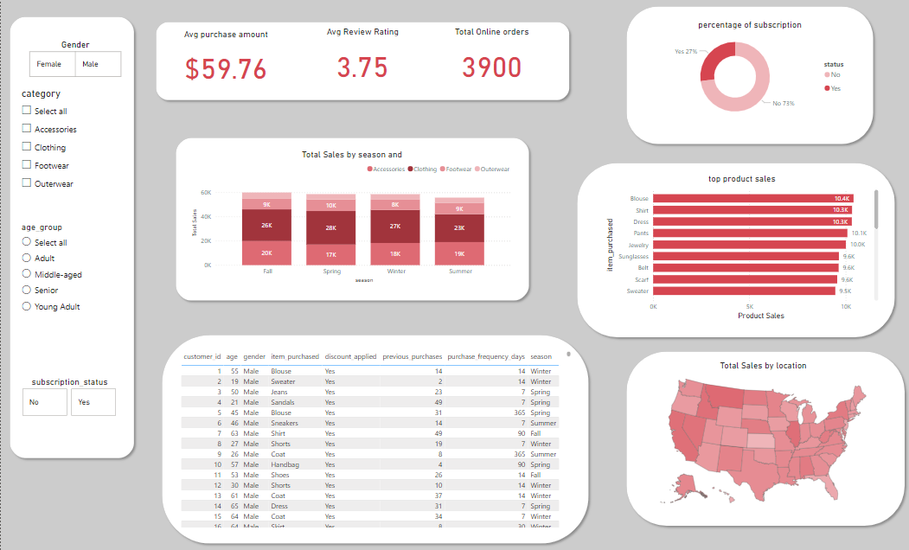Key Dashboard Components:
- KPIs: Average purchase value, total orders, average rating
- Subscription Distribution: Subscriber vs non-subscriber comparison
- Seasonal Sales Trends: Sales performance by season and category
- Top Products: Best-selling products by revenue
- Customer Filters: Gender, age group, category, subscription status
- Geographic Map: Location-based sales overview
The dashboard enables stakeholders to explore insights dynamically and make data-driven decisions without technical expertise.

6. Key Findings Summary
- Most of the revenue comes from Young Adult and Adult customers.
- Subscribers exhibit higher purchase frequency and loyalty yet represent a smaller portion of the customer base.
- Discounts increase customer engagement without significantly reducing purchase value.
- Clothing categories dominate overall sales performance.
- Sales peak during Spring and Fall, indicating strong seasonal demand patterns.
- A small segment of loyal customers contributes a disproportionate share of revenue.

7. Business Recommendations
Based on the analysis, the following strategic recommendations are proposed:
- Increase Subscription Adoption Introduce exclusive subscriber benefits such as free shipping, early access to sales, and loyalty rewards.
- Strengthen Customer Retention Programs Focus on converting returning customers into loyal customers through personalized offers.
- Optimize Discount Strategy Use targeted discounts rather than blanket promotions to protect profit margins.
- Focus on High-Performing Products Prioritize inventory and marketing efforts on best-selling and top-rated products.
- Leverage Seasonal Trends Align product launches and campaigns with high-demand seasons.
- Enhance Customer Experience Improve product quality and delivery to boost review ratings and repeat purchases.

8. Conclusion
This customer shopping behaviour analysis demonstrates how structured data preparation, behavioural segmentation, and interactive visualization can uncover actionable retail insights. By leveraging these findings, the company can improve customer engagement, increase revenue, and build long-term customer loyalty through informed strategic decisions.

